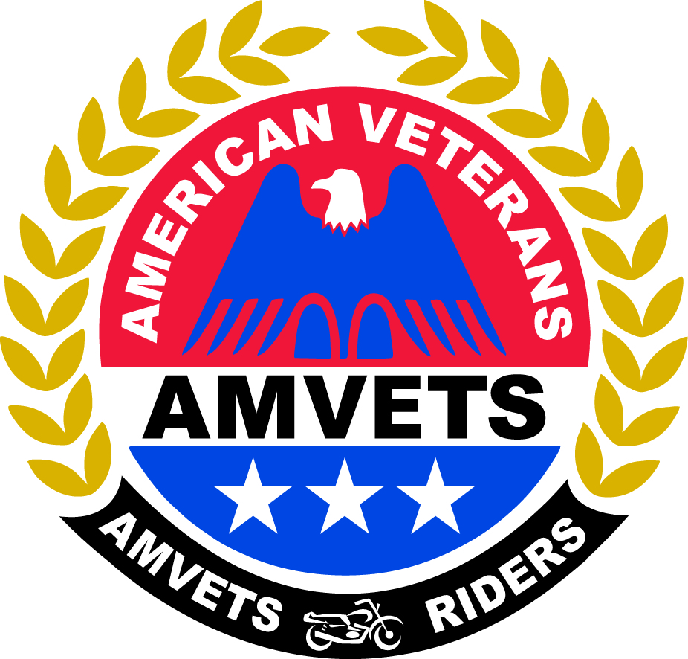
National AMVETS Riders
Mid-Year Rally 2022
Registration Form
RETURN FORM WITH FEES TO:
Riders National Treasurer
1603 Ridge Bend Dr.
Glencoe, MO 63038

NOTE: PLEASE USE ONE FORM PER PERSON

Name:  (Please Print) | Date:
Department (State): | Chapter #/Officer Position (if applicable):
Phone Number: | Email Address:

Please check (√) how you are registering:

National  Officer | Past National  President | Dept.  Delegate | Alternate  Dept.  Delegate |  | Chapter  Delegate | Alternate  Chapter  Delegate | Non  Voting  Member/Other
ALL RIDERS ATTENDING MID-YEAR MUST REGISTER, INCLUDING ANY SUPPORTERS/NON-VOTERS
The 2022 Mid-Year Rally will be held 28-30 April 2022 at MO-48 in DeSoto, MO. To be eligible as a delegate at the Mid-Year Rally, you must be current with your parent organization and Riders dues.
The deadline for pre-registration forms to be submitted (and post marked) to the address above is April 4th.
Pre-Registration fee is $10.
If you do not pre-register, you will need to register at the door and pay $20.
PLEASE MAKE A COPY OF THIS FORM AND SHOW IT TO THE CREDENTIAL COMMITTEE UPON REGISTRATION.
DELEGATES will be based on the number of RIDING members at the Chapter level. 1-50 riding members get two delegates and two alternates. You may add one delegate and one alternate for each additional 50 riding members. The Chapters are responsible for appointing delegates and alternates. In addition, each Riders Department President or his elected representative will constitute a National Delegate - each of whom also has one vote.

T-SHIRTS Mid-Year event T-shirts will be $15 if ordered and paid for when you pre-register. Shirts purchased at Mid-Year will be $20.

Please mark below the size and number of shirts needed and include your payment when sending your registration.

T-SHIRTS | S ($15) | M ($15) | L ($15) | XL ($15) | 2X ($15) | 3X ($15) | 4X ($15)
Please
Indicate Size and Quantity

